**Question Paper 2**

**Solution for Q1**

% Load the symbolic package (only needed once per session)

pkg load symbolic

% Define the range of x values

x = linspace(-3, 3, 1000);

% Define the polynomial P(x)

P = @(x) x.^5 - 4*x.^4 + 3*x.^3 - 2*x.^2 + x - 1;

% Compute derivatives manually

P1 = @(x) 5*x.^4 - 16*x.^3 + 9*x.^2 - 4*x + 1; % First derivative P'(x)

P2 = @(x) 20*x.^3 - 48*x.^2 + 18*x - 4; % Second derivative P''(x)

% Plot P(x), P'(x), and P''(x)

figure;

hold on;

plot(x, P(x), 'b', 'LineWidth', 2); % P(x) in Blue

plot(x, P1(x), 'r', 'LineWidth', 2); % P'(x) in Red

plot(x, P2(x), 'g', 'LineWidth', 2); % P''(x) in Green

% Add labels and title

xlabel('x');

ylabel('Function Values');

title('Plot of P(x), P''(x), and P''''(x)');

legend('P(x)', 'P''(x)', 'P''''(x)');

grid on;

hold off;

Graph for Q1

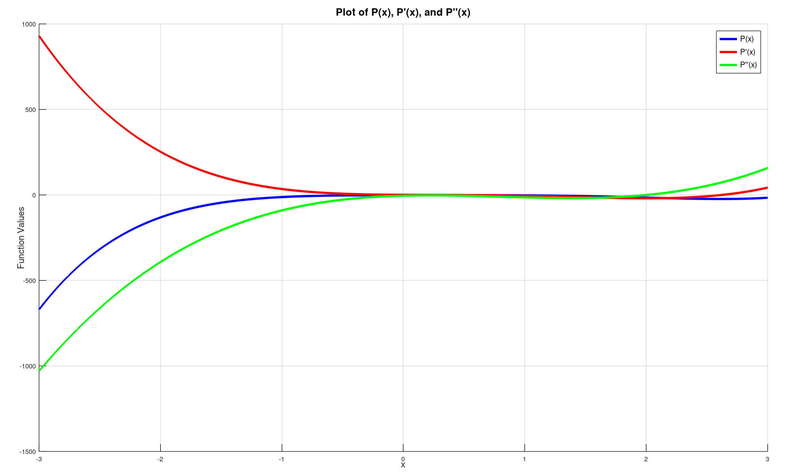

**Sol for Q2**

% Define constants

a = 2;

b = 2;

c = 1;

% Define the range for x and y

x = linspace(-3, 3, 50);

y = linspace(-3, 3, 50);

% Create a meshgrid

[X, Y] = meshgrid(x, y);

% Compute Z for both positive and negative sheets

Z_square = (X.^2 / a^2) + (Y.^2 / b^2) - 1; % Rearranged hyperboloid equation

% Only take real values where Z^2 is positive

valid_idx = Z_square >= 0;

Z_pos = zeros(size(Z_square));

Z_neg = zeros(size(Z_square));

% Compute Z only where it's valid

Z_pos(valid_idx) = sqrt(Z_square(valid_idx)) * c;

Z_neg(valid_idx) = -sqrt(Z_square(valid_idx)) * c;

% Plot the hyperboloid sheets

figure;

hold on;

surf(X, Y, Z_pos, 'FaceAlpha', 0.7, 'EdgeColor', 'none'); % Positive sheet

surf(X, Y, Z_neg, 'FaceAlpha', 0.7, 'EdgeColor', 'none'); % Negative sheet

% Formatting

xlabel('X-axis', 'FontSize', 14);

ylabel('Y-axis', 'FontSize', 14);

zlabel('Z-axis', 'FontSize', 14);

title('Hyperboloid of Two Sheets', 'FontSize', 16);

colormap jet;

colorbar;

grid on;

axis equal; % Ensure aspect ratio is equal for all axes

view(3); % Set 3D view

hold off;

**Graph for Q2**

